**From this…**

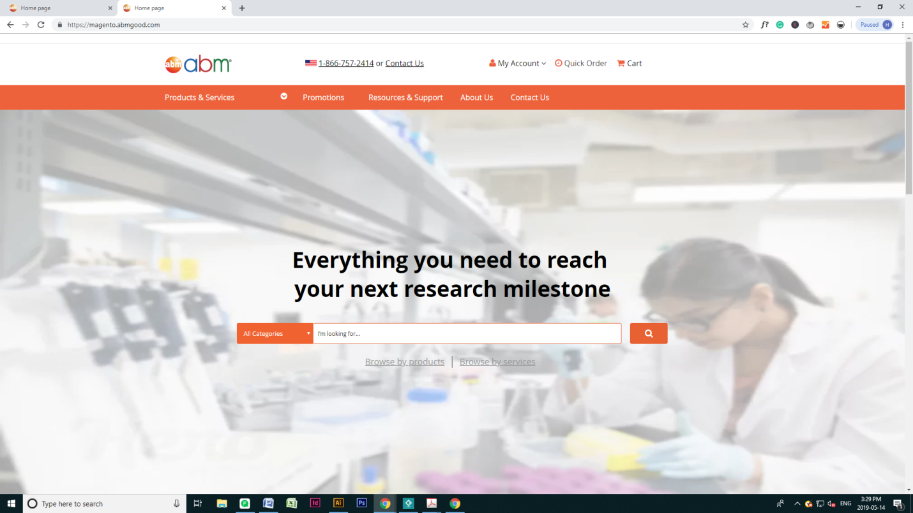

**To something like this…**

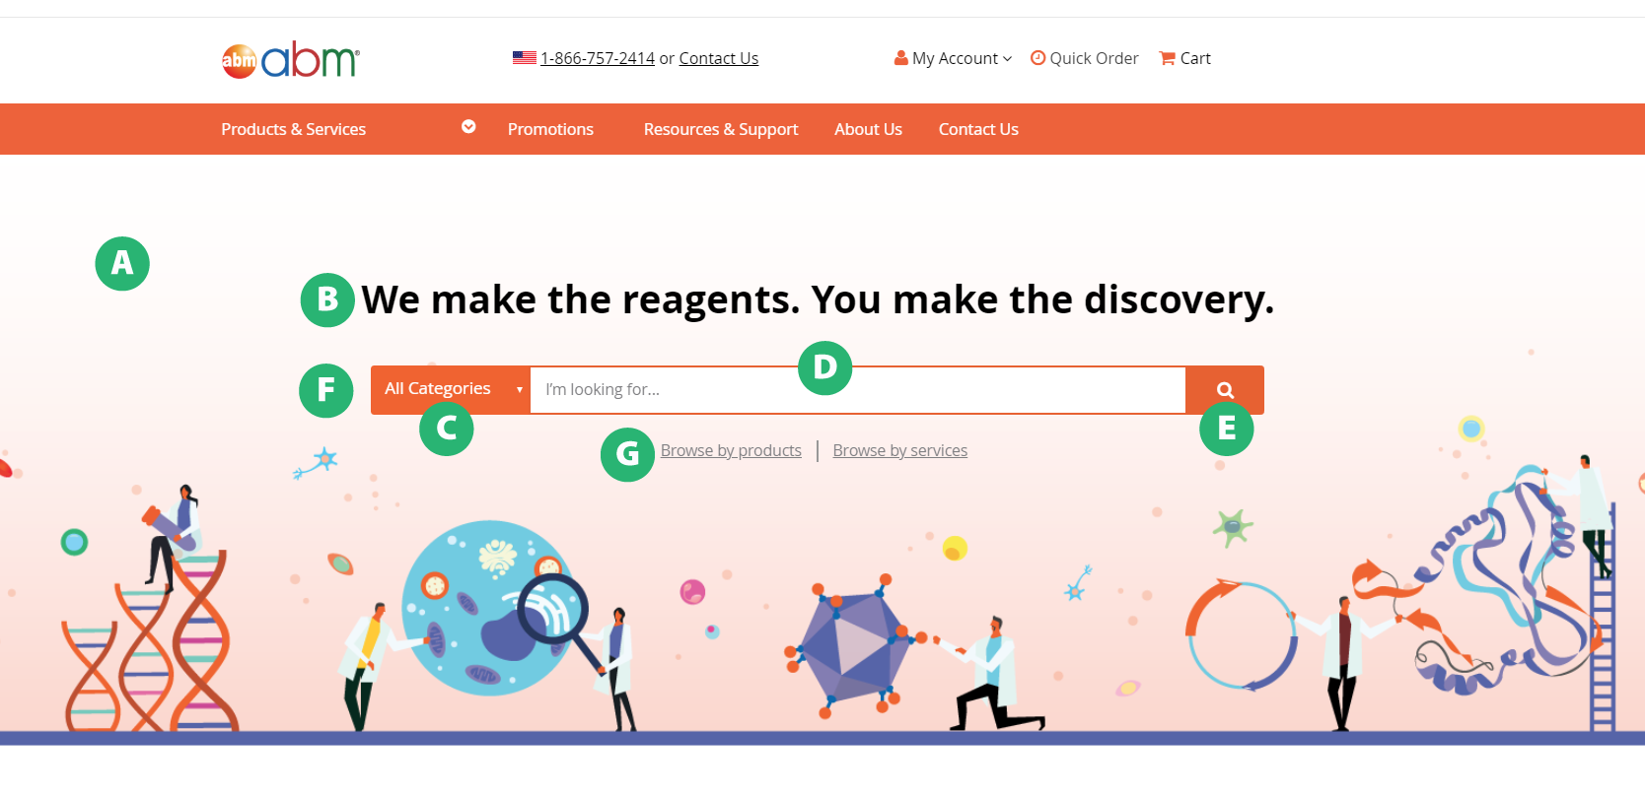

* **A: Banner**
  + Update image with the attached new image
  + height: 600px;
  + background-size: cover;
    - [I don’t want the image to stretch like it does currently]
  + background-position: bottom;
* **B: H1**
  + Update text to: We make the reagents. You make the discovery.
    - [All in one line, so remove the <br>]
  + font-size: 3em;
    - [Sorry – I know you helped me adjust this last time, but I want to reduce font size now that we have a longer line of text
  + Reduce the padding on top of the heading to 120px
* **C: All categories dropdown menu**
  + font-size: 1.2em;
  + Do you know if I can play around with the style of the dropdown menu in Chrome’s inspect mode? Or, should I just give you an image of how I want to make it look?
* **D: White search box**
  + Increase border stroke to 2px
  + Remove border-radius
  + Text inside search box:
    - padding-left: 15px;
    - font-size: 1.2em;
    - color: #808083;
      * Can you make this color: #000; when user begins typing?
* **E: Search button**
  + Remove margin-left: 1em;
  + border-radius: 0 4px 4px 0;
* **F: Search bar (entire)**
  + Increase height to 50px
  + Can you make the width of the bar a fixed size for non-mobile screens (define different style for tablet + mobile) – example of what I mean: <https://www.abcam.com/>
    - Currently, the bar changes width along with the screen width
* **G: Browse by products | Browse by services**
  + color: #808083;
  + font-size: 1.2em;